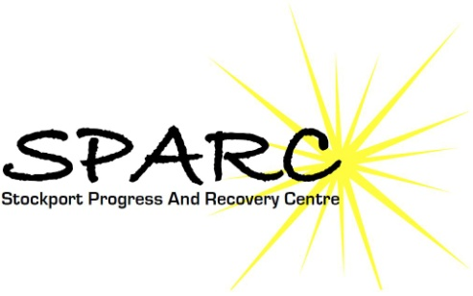

Progress House,
35A Adswood Lane East,
Stockport, SK2 6RE.
Tel: 0161 429 9744
Fax: 0161 476 6429
email: info@sparc4me.org.uk
website: sparc4me.org.uk

Reference for Gravitas Outcome Services

My name is Lynn Barrett and I am the manager of Stockport Progress And Recovery Services which is a voluntary organisation providing support and therapeutic activities for people in the local area who experience mental health problems.

Our relationship with Gravitas Outcome Services was established several years ago when they came to our rescue by providing us with CORS (Case Outcome recording System). Gravitas have quite literally brought our service into the 21st century by providing training and technology that has delivered a huge positive change that has been of benefit to our service users and other stakeholders alike.

Gravitas are a responsive and forward thinking infrastructure support service that has been able to adapt and evolve along with the need of their clients. With their involvement our service can now confidently provide funders with statistics and reports that support the anecdotal evidence. The CORS database provides me as the manager with the ability to oversee the service to ensure that the service is delivering person centred outcomes and provides me with the confidence of being able to prove this in a concrete way. The system has been designed to be user friendly and is easy to use and understand. Working within this system has also created questions and queries as to how to improve the service and implement outcome processes in other areas of our work and Gravitas have worked with us to create new ideas and ways of working.

I have every confidence in the way that Gravitas work and have no hesitation in recommending them to other services.

